As American as Apple Pie

Recipe makes 2 pies. (Because 1 is never enough)

**Ingredients:**

3 Tart apples (I use Granny Smith)

9 Filler Apples: (I like to use some sweet and some generic ones. In this example I’m using 6 honey crisp and 3 Fiji)

Cinnamon: (To taste)

Apple Cider: (I use Red’s apple Ale ‘cause it’s what I have on hand)

Nutmeg: (Freshly ground is worth it if you have time.)

Sugar: (Half cup-ish)

4 pie crusts: (I like Pillsbury)

(Experimental ingredients)

Gelatin mix: (A lil sprinkle)

Bread flour: ~1/2 cup

**Method:**

1. Pull out your pie crusts from the refrigerator. They need time to become pliable.
2. Cut 1/3rd of your apples into chunks your blender/food processor can puree. Coat with a spoonful of sugar, add nutmeg and cinnamon until it smells like Christmas. *(Experimental) Add gelatin mix, brown sugar (2 spoonfuls) and bread flour.* Toss in large bowl.   
   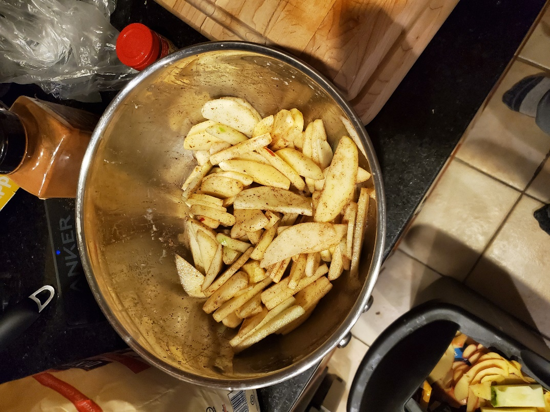
3. Blend until it is a chunky goop.

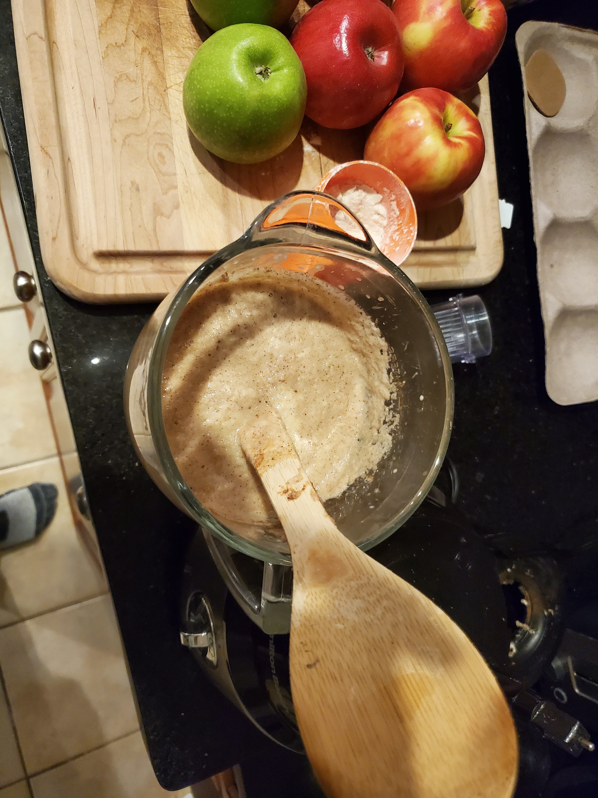

1. Cut the other 2/3rd Apples coat with cinnamon, sugar, and cider. (Do not include flour, gelatin, or brown sugar) Pro-tip: You can eat some of the apple slices, they’re pretty tasty.
2. Lay down crust into pie tin and then pour 1/4th your apple pie mix into the tin. Add apple slices in a spiral pattern to increase pie density. Pour in the remaining ½ blend on top. If you have juices in your tossing bowl pour that on top as well.

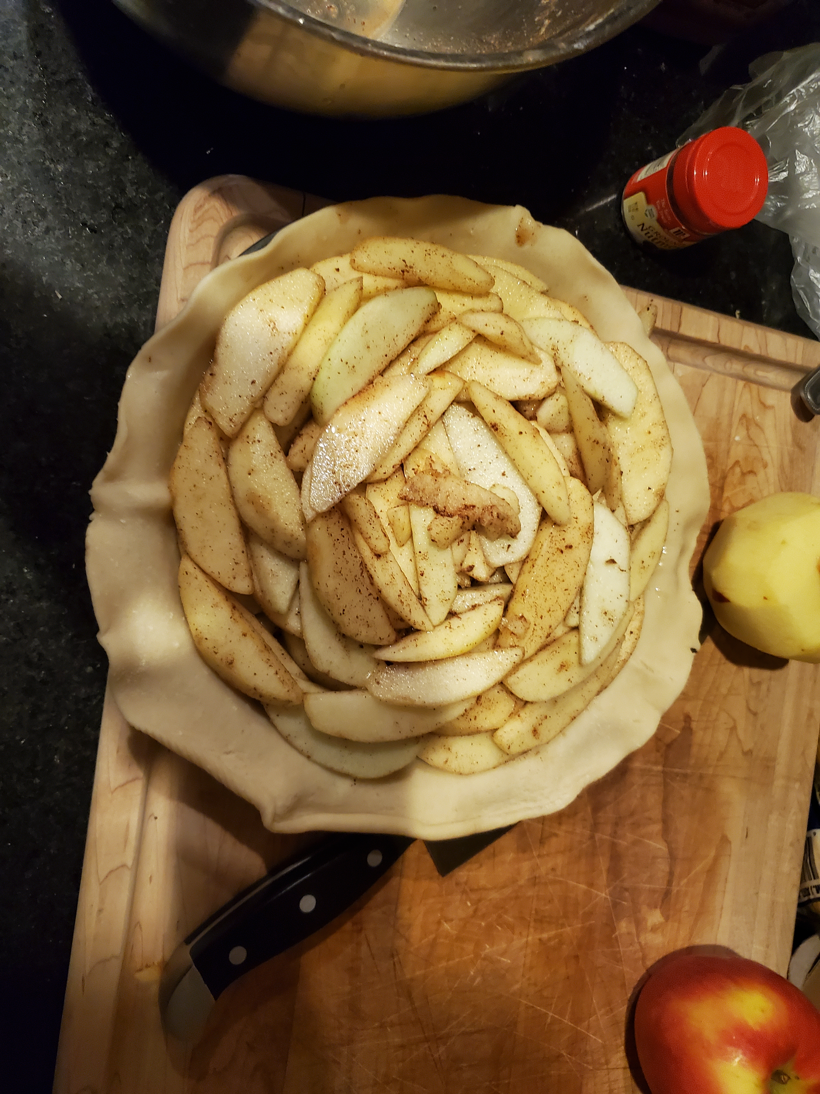

1. Using a pie cutter, slice the next pie crust into strips. Strip thickness is personal preference, I usually use 2 fingers, since I am documenting it and wanted to try being fancy I did just 1 finger width. Take every other slice and set it aside. 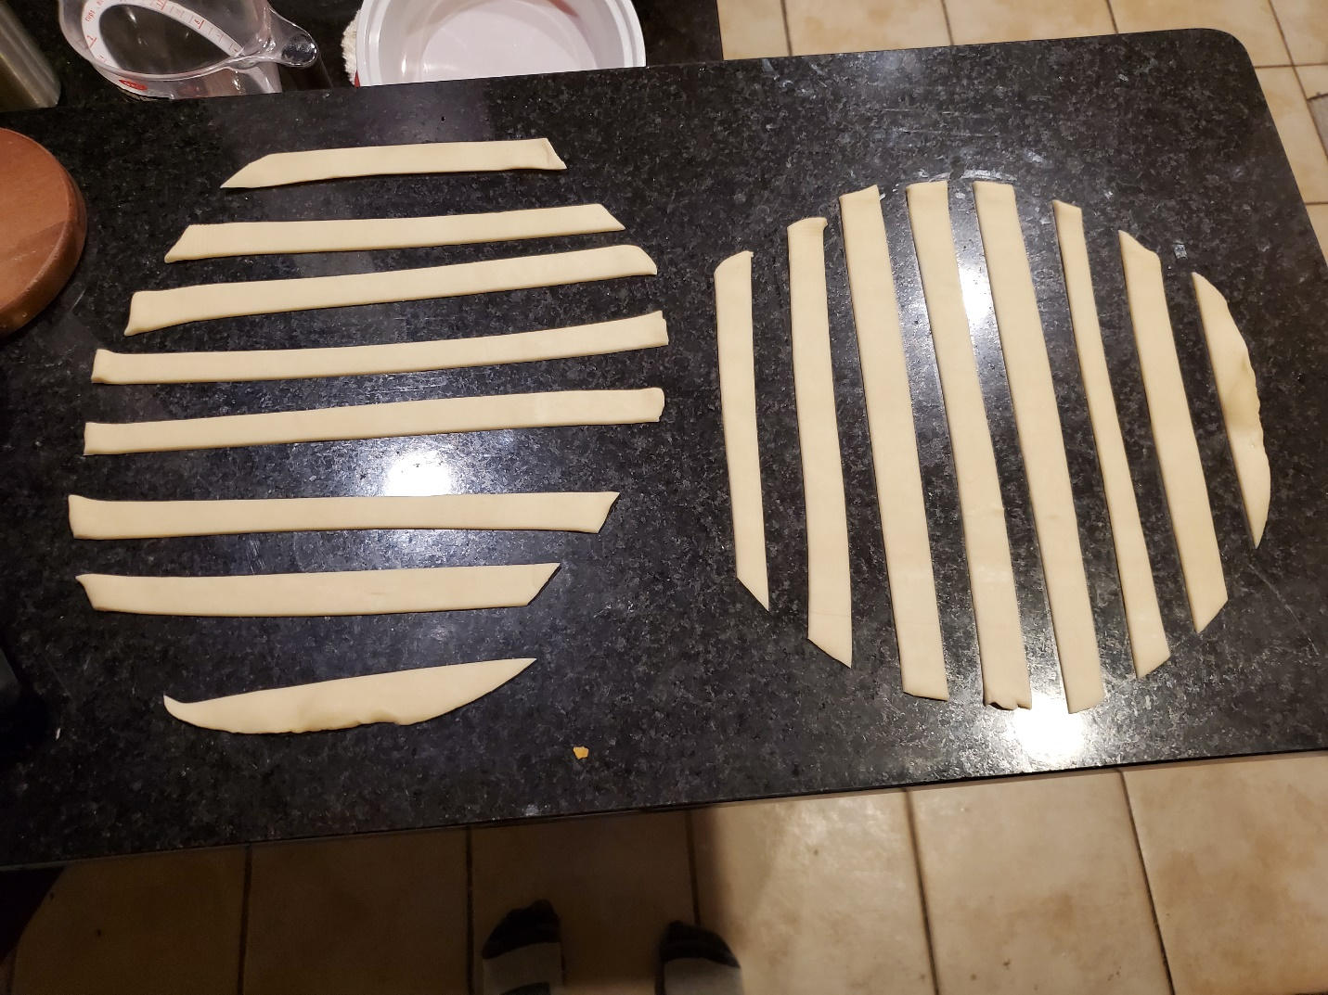
2. Lace it together in a knitted pattern, I like to do a ~30* twist to the lacing to make it look fancier. Do what you want, but remember to leave open spots for the steam to vent. Your pie will explode if you just cover it. A sugary bomb is not something you want to clean out of a hot oven. Tip: You can dip your fingers in cider and coat the strips to make them slide a bit if you want to readjust them after lacing.  
    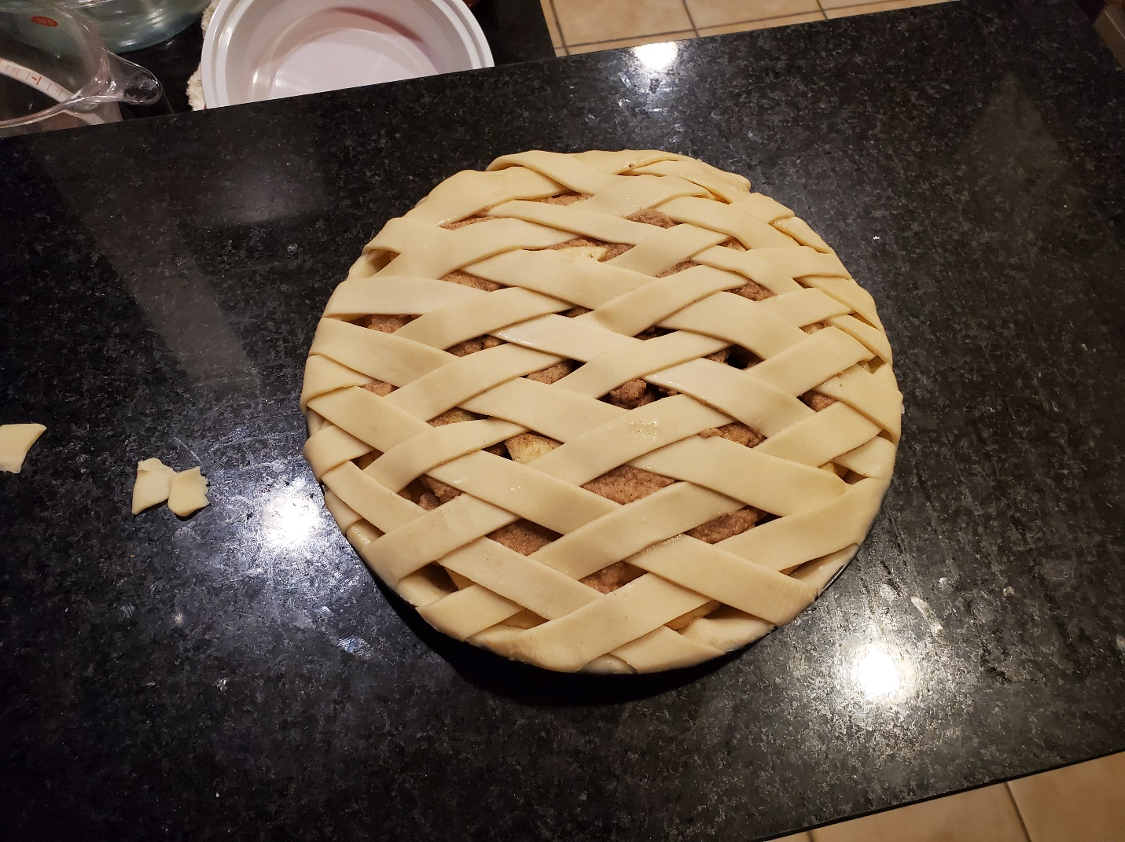
3. Bake on bottom of oven at 425 until Golden brown and delicilous ~ 45 minutes. I like to bake it on top of a cookie tray with parchment paper, because sometimes it bubbles and leaks.
4. If it’s not golden brown, but looks done; move to top rack and turn on broiler. Watch it because it does not take long.

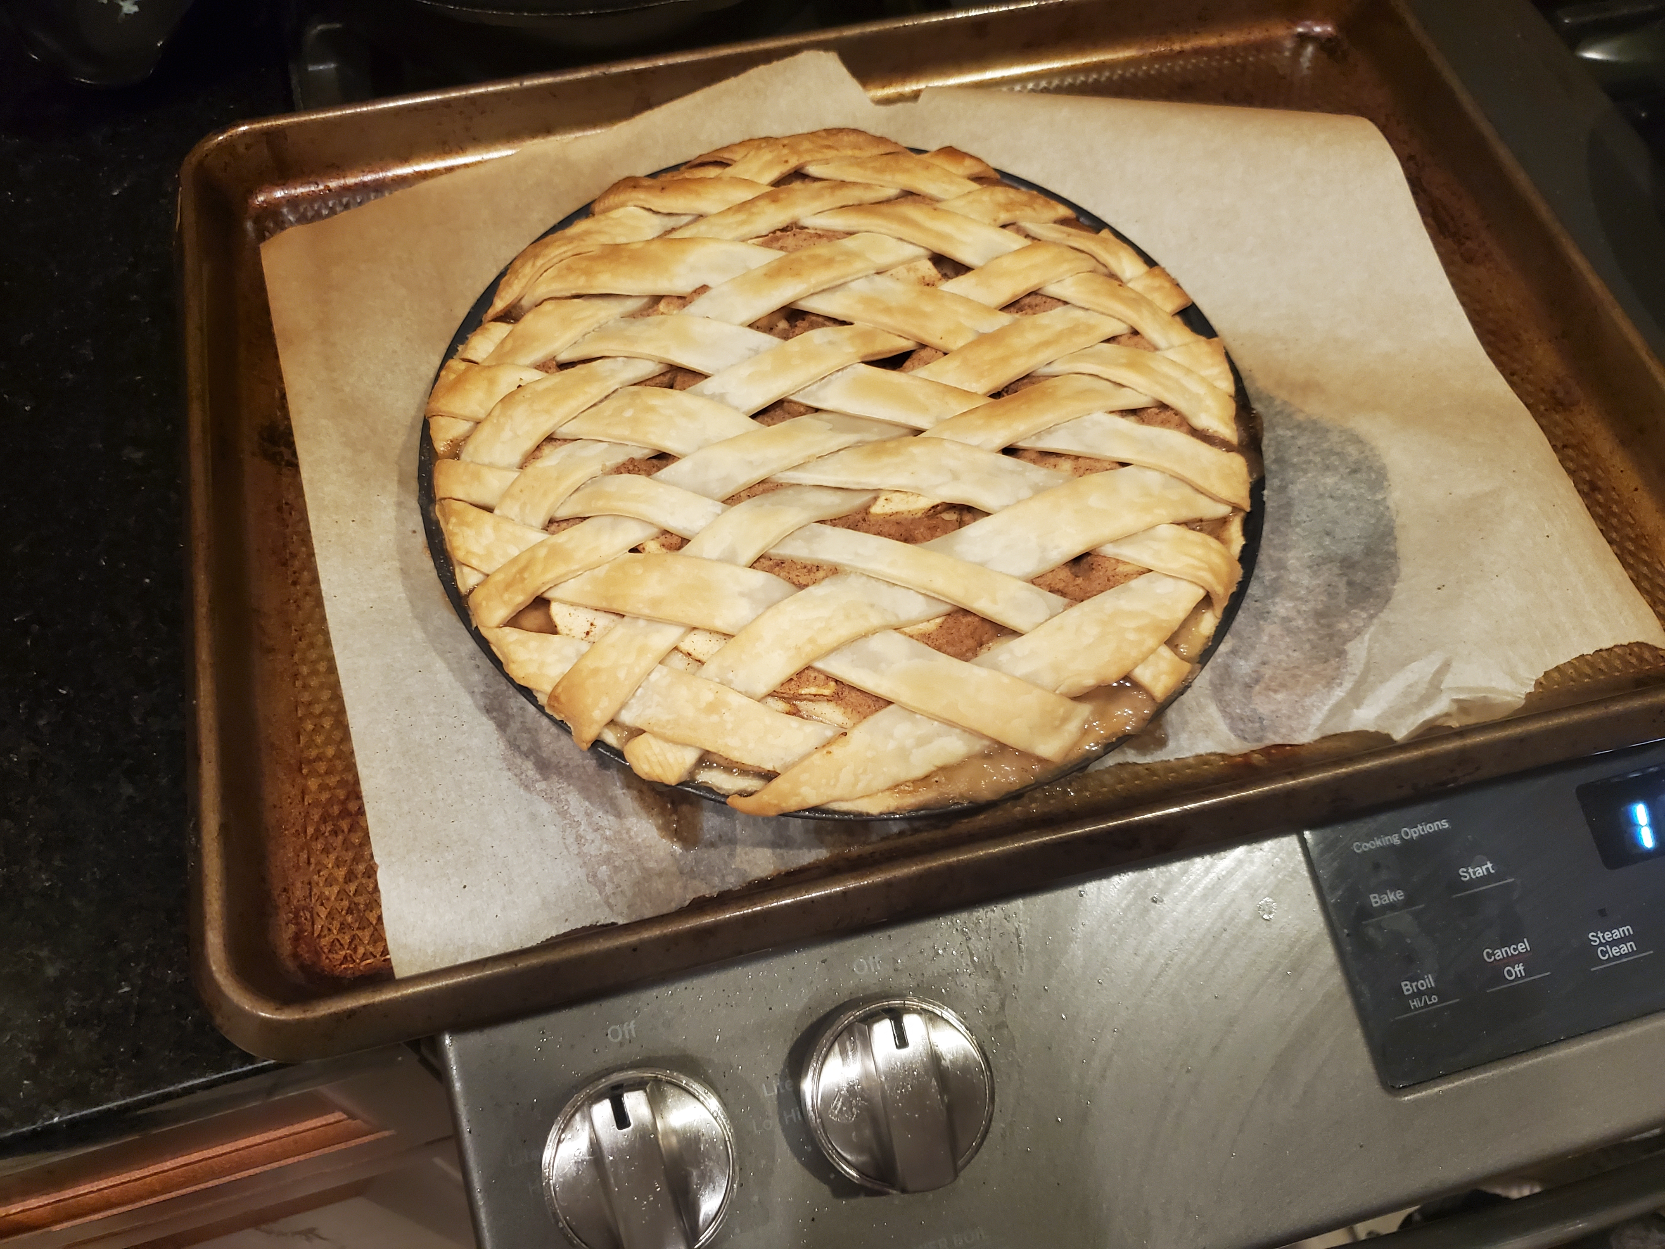

1. Let cool for ~ 4 hours. It is a sugary fire bomb, you do not want to burn your mouth and you should not rapidly cool it least you ruin the pie. (I’ve tried; it doesn’t work.)